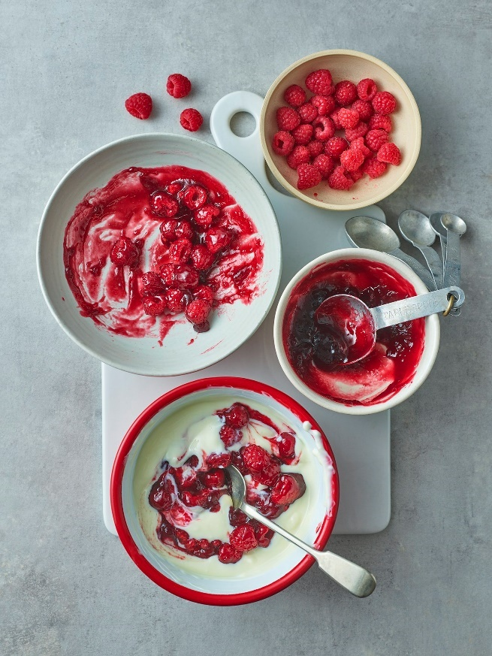
Header image: ‘Welcome to Carnation’

<first name>, welcome to our Carnation baking community!
We thought we would send you our most loved recipes for baking inspiration to get you started. We’ve got you covered for every occasion! You can rate & review them online & share your bakes with our community on social media!
We can’t wait to see your creations
Happy Baking,
From Carnation

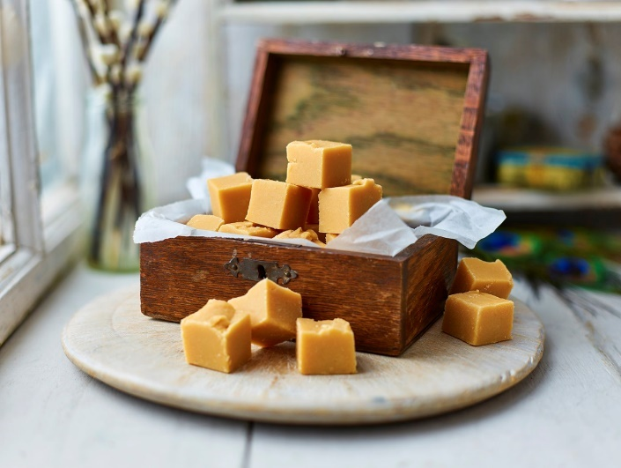
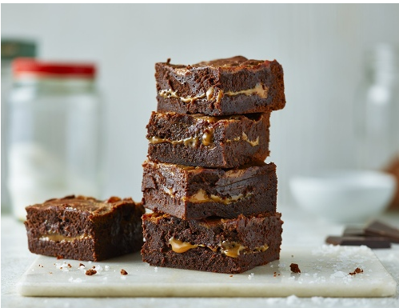
Fudge & Sweets
Caramel

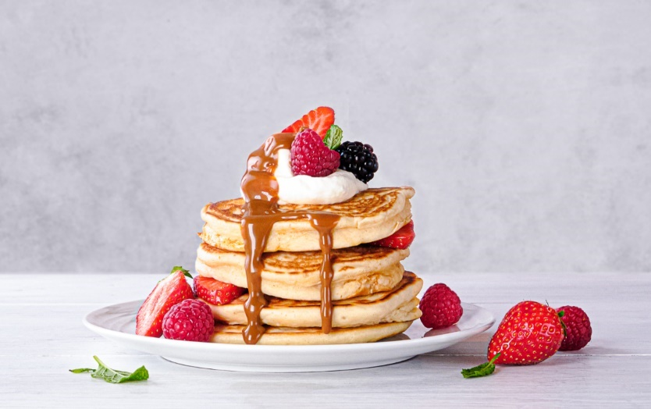
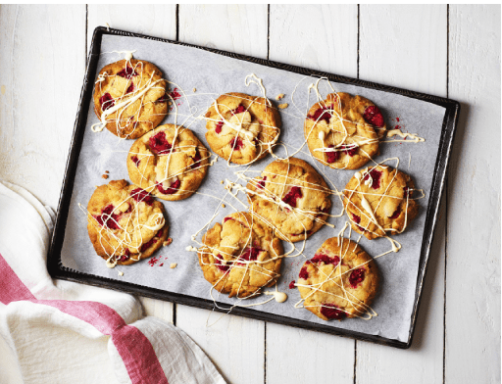
30 mins or less
Family
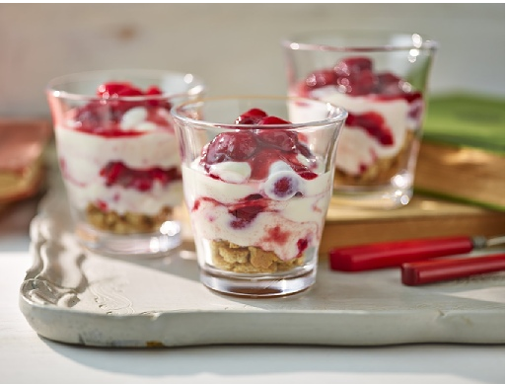
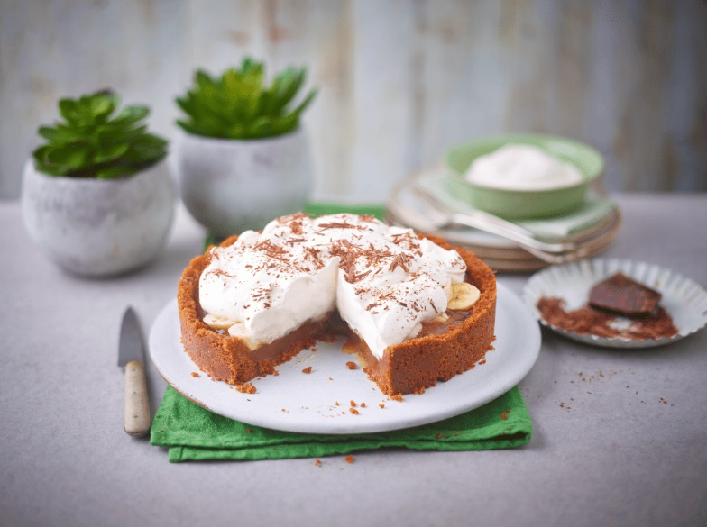
Lighter
Vegan





